**What are the common mistakes when choosing clothing sizes?**

1) Choosing the size based only on your height or weight, both must be accurate.

2) Simply choosing the size which you normally wear comfortably.

Please remember there are thousands of clothing manufacturers. Due to different measurement systems, there may be slight variations in size standards. Both methods can lead to incorrectly fitting clothes.

**So how do I select the right size?**

1) Correctly measure your body size.

2) Generally speaking, clothing sizes are slightly larger than the actual human body size. When women purchase clothing, the bust size of the clothes should ideally be 2-4 inches larger than the physical body size. Similarly, the bust size of men’s clothing should be 4-6 inches larger than the body size, and the clothing waist size between 0.8 to 1.6 inches larger than the body size. For winter coats, the size discrepancy should be slightly larger than the above quoted numbers. (The information above is for reference only, with specific differences depending on your personal taste, seasonal style, and clothing fabric).

3) You can tile the most comfortable clothes which you usually wear, measuring the bust waist hips, and other areas, and then compare the measurements to the size chart. Simply select the nearest size.

**How to measure women’s clothing**

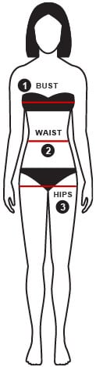

To choose the correct size for you, measure your body as follows:

*1* BUST

Measure around the fullest part of the bust

*2* WAIST

Measure around the waist at the narrowest point

*3* HIPS

Stand with hills together and measure around the fullest part of the hips

TIPS:

Always hold the measuring tape loosely to ensure you get the right result.